ORE HOUSE HILLTOP TAVERN MENU

LOOKING FOR A QUICK BITE?
APPETIZERS
Our appetizers pair well with a tasty cocktail or cold draft beer. Try one today!

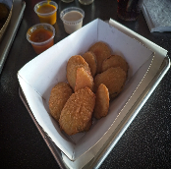  Fried Zucchini Slices  Lightly battered, deep-fried zucchini slices $ 8.45 | 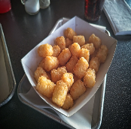  Crispy Beer-Battered Tater Tots  Beer-Battered and deep-fried until they are golden Brown and Crispy! $ 4.45
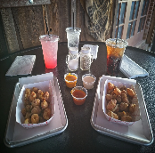  Fried Cheese Curds  Lightly breaded chunks of mild jalapeno cheese. $ 8.45 | 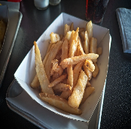  Crispy Beer-Battered French Fries  Crispy beer-battered French fries fried to a delightful crispy crunch. $ 4.95
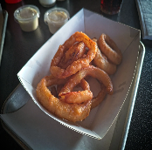  Crispy Onion Rings  Crispy Beer Battered $ 6.95 | 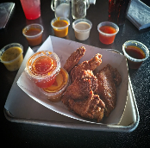  1/2 Dozen Chicken Wings  Your wings come with your choice of naked wings, or for $1 more, get ’em tossed in buffalo, spicy buffalo, sweet chili, mango habanero, garlic parmesan, bbq or stinging honey bbq. One sauce flavor per order. $ 8.95
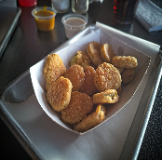
Crispy Fried Pickles
Battered pickle slices deep fried to a crispy perfection. $ 8.45
FLOUR OR CORN TORTILLA
STREET TACOS
Two street tacos on your choice of tortilla.

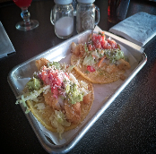
Two Street Tacos
Two street tacos on your choice of flour or corn tortillas that include Mexican cotija cheese, house made Pico, chipotle mayo, guacamole and your choice of House-smoked meat, fried shrimp or beer-battered fish. $ 7.95
HOUSE-SMOKED FRESH ANGUS BEEF PATTIES
SMOKE'N BURGERS
Choose your favorite burger and pair it with a side serving of house coleslaw for $3, French fries or tater Tots $4 or Onion Rings $5.50 additional.

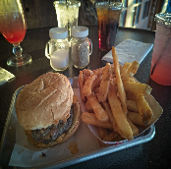  Journeyman Burger  House-smoked beef patty served with lettuce, tomato, onions and pickles on a toasted bun. $ 7.45 | 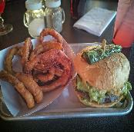  El Hefe Burger  House-smoked Angus beef patty covered in house guacamole, deep-fried jalapenos, chipotle mayo and Pepper jack cheese. $ 10.95
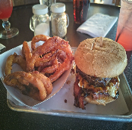  Just Shroom’n Burger  House-smoked Angus beef patty piled high with sauteed red onions & mushrooms, chipotle mayo and melted Swiss Cheese served on a toasted bun. $ 9.95 | Pineapple Express Burger  House-smoked Angus beef patty with house-made pineapple & jalapeno crème cheese mix, chipotle mayo, teriyaki sauce, jalapeno bacon and Pepper jack cheese. $ 10.95

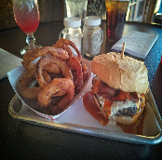
Bleu Buffalo Burger
House-smoked Angus beef patty lathered up good with our own blue cheese concoction, jalapeno bacon and a slight drizzle of Buffalo sauce. $ 10.95

CHICKEN, SHRIMP OR FISH!
MEAL BASKETS
Our meal baskets include the 3 main tavern food groups of chicken, shrimp or fish. All of our baskets include your choice of fresh crispy beer-battered fries, tater tots or house-made coleslaw, Onion rings are $1.50 extra.

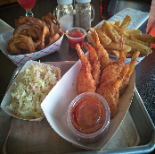  One-half Dozen Butterfly Shrimp  Six battered and deep-fried butterfly shrimp. Try ’em with our house-made spicy cocktail sauce! $ 11.95 | 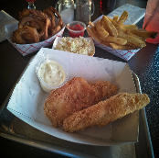  Beer Battered Fish  Two tender and juicy deep-fried Cod fillets. Add an extra piece of Cod for $3. Includes your choice of crispy beer -battered fries, tater tots or fresh house-made coleslaw. $ 10.95
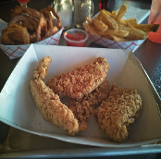
Chicken Fritters
Lightly battered deep-fried tenderloins with your choice of dipping sauce; buffalo, spicy buffalo, sweet chili, mango habanero, garlic parmesan, bbq or stingin’ honey. $ 10.95

3 SANDWICH CHOICES SURE TO PLEASE!
SANDWICHES
Whether it's our house-smoked pulled pork, a blazin' BLT or our own dynamite chicken sandwich, we've got the sandwich for you! Add a side order of Tots or Fries.

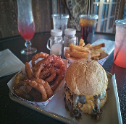  Smoked Brisket Sandwich  One of our latest editions to the menu is our brisket sandwich. This sandwich features our tender and tasty house-smoked brisket topped with Pepper jack cheese, sauteed onions and mushrooms with our very own chipotle mayo, served on a toasted bun. $ 11.95 | 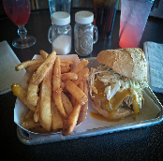  Pull’n It Off  House smoked pulled pork with pickles, house BBQ sauce and topped with fresh-made coleslaw. Served on a toasted bun. Add spicy green chili’s for $1.50 $ 10.95
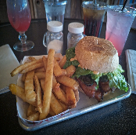  Blazing Bacon Lettuce and Tomato  Our version of a ramped-up BLT with 4 slices of jalapeno bacon, deep fried jalapeno halves, house-made chipotle mayo, lettuce and tomato served on a toasted bun.  $ 10.95 | 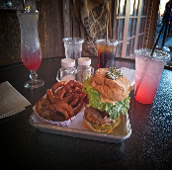  Dynamite Chicken Sandwich  Breaded Chicken with Chipotle Mayo, pepper jack cheese, lettuce, tomato and bacon topped with a fried jalapeno served on a toasted bun. $ 11.95

Hours of Operation
Monday, Wednesday, Thursday & Sunday 11-9
Friday & Saturday 11-11
We're Closed on Tuesday's

Address – 1200 N Jefferson Dr, Oracle, Az 85623 Phone – 520.896.3334

